IoT Student Tracker Design Document

Table of Contents

1. Introduction

2. Project Overview

3. Objectives

4. Scope

5. Requirements

6. Architecture

7. User Interface Design

8. Data Model

9. Testing Strategy

10. Deployment Plan

11. Maintenance Plan

12. Glossary

1. Introduction

In today's educational landscape, efficient attendance management is crucial for ensuring student engagement and accountability. Traditional methods of attendance tracking often prove to be cumbersome and prone to errors, leading to inefficiencies in academic administration. Recognizing the need for a modern and streamlined solution, the IoT Student Tracker project emerges as an innovative platform designed to revolutionize attendance monitoring in educational institutions.

The IoT Student Tracker leverages the power of Internet of Things (IoT) technology and the MERN (MongoDB, Express.js, React.js, Node.js) stack to create a comprehensive and user-friendly system for tracking student attendance in real-time. By seamlessly integrating hardware components such as ESP32 microcontrollers and RFID modules with a web-based interface, the project offers a sophisticated yet intuitive solution for both teachers and students.

This groundbreaking initiative not only simplifies the process of attendance management but also enhances data accuracy and accessibility. Through the use of RFID cards assigned to each student, the system automatically records attendance as students enter the classroom, eliminating the need for manual intervention and minimizing the risk of errors. Furthermore, the web application provides administrators with a centralized platform to register new students, monitor attendance trends, and communicate effectively with their students.

With its emphasis on efficiency, reliability, and user-centric design, the IoT Student Tracker project aims to empower educational institutions with the tools they need to streamline administrative processes, foster student engagement, and ultimately, elevate the quality of the learning experience. By harnessing the potential of IoT technology, this project represents a significant step forward in the modernization of educational administration, paving the way for a more connected and dynamic educational ecosystem.

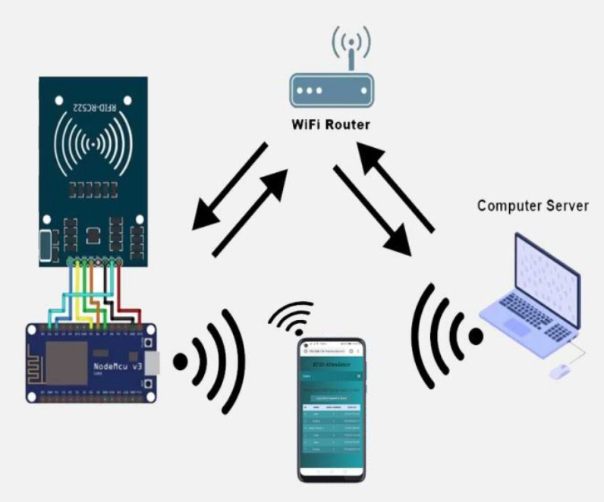

2. Project Overview

In an era characterized by rapid technological advancement, the IoT Student Tracker emerges as a pioneering solution at the intersection of education and IoT innovation. This groundbreaking project seeks to address the challenges associated with traditional attendance management systems by harnessing the power of IoT technology and modern web development frameworks.

At its core, the IoT Student Tracker is designed to provide educational institutions with a comprehensive and efficient tool for managing student attendance. By integrating hardware components such as ESP32 microcontrollers and RFID modules with a web-based interface built on the MERN (MongoDB, Express.js, React.js, Node.js) stack, the project offers a seamless and intuitive solution for both administrators and students alike.

One of the key features of the IoT Student Tracker is its real-time attendance tracking capability. Through the use of RFID cards assigned to each student, the system automatically records attendance as students enter the classroom, eliminating the need for manual attendance-taking and minimizing the risk of errors. This not only streamlines the attendance management process but also provides administrators with up-to-date insights into student attendance patterns and trends.

Furthermore, the IoT Student Tracker empowers administrators with a range of administrative capabilities through an intuitive web-based interface. Administrators can register new students, manage student profiles and attendance records, and communicate effectively with students through the platform. Additionally, students have access to a dedicated portal where they can view their attendance records, update their personal information, and communicate with administrators as needed.

By leveraging IoT technology and modern web development practices, the IoT Student Tracker project aims to revolutionize attendance management in educational institutions. By providing administrators with powerful tools for tracking attendance and engaging with students, and by empowering students with greater visibility and control over their own academic records, the project seeks to enhance the overall efficiency, transparency, and effectiveness of educational administration. In doing so, the IoT Student Tracker project represents a significant step forward in the ongoing evolution of education in the digital age.

3. Objectives

**Admin Panel for Student Registration:**

* Teachers can register new students through an intuitive admin panel.
* The admin panel includes a student registration form where teachers can input student details such as name, ID, and class information.

**Real-Time Attendance Tracking with RFID Technology:**

* The system integrates with RFID technology for real-time attendance tracking.
* Each student is assigned a unique RFID card, which they can use to scan upon entering the classroom.
* The RFID scanner communicates with the web application, automatically recording student attendance in real-time.

**Student Portal for Attendance Records:**

* Students have access to a dedicated portal where they can view their attendance records.
* They can see their attendance history, including dates and statuses (present/absent), providing transparency and accountability.

**Personal Details Management:**

* In addition to attendance records, students can also view and update their personal details through the student portal.
* This feature allows students to keep their information up-to-date, ensuring accuracy in administrative records.

**Direct Communication Between Students and Teachers:**

* The web interface facilitates direct communication between students and teachers.
* Students can send messages to teachers through the platform, enabling seamless interaction and support.

4. Scope

* **Efficiency:** Streamlines administrative tasks such as student registration and attendance tracking, saving time and resources.
* **Accuracy:** Real-time attendance tracking reduces the risk of errors and ensures accurate record-keeping.
* **Transparency:** Provides students with visibility into their attendance records, promoting accountability and engagement.
* **Communication:** Facilitates communication between students and teachers, fostering a supportive learning environment.

With its comprehensive feature set and user-friendly interface, the IoT Student Tracker project aims to modernize attendance management in educational institutions, contributing to improved efficiency, transparency, and student engagement.

5. Requirements

**Functional Requirements:**

1. Admin Panel:

* Register new students with personal details.
* Scan RFID cards to assign unique IDs to students.
* View attendance records of all students.

1. Student Panel:

* View personal details.
* View attendance records.
* Send messages to the admin.

**Non-Functional Requirements:**

* Real-time attendance tracking.
* Security measures to prevent data tampering.
* User-friendly interface for both admin and students.

6. Architecture

The system architecture consists of:

* **Frontend:** React.js for admin and student panels.
* **Backend:** Node.js and Express.js for API development.
* **Database:** MongoDB for storing student and attendance data.
* **Hardware Integration:** ESP32 and RFID modules for attendance tracking.

7. User Interface Design

The user interface design includes:

* **Admin Panel:** Dashboard for managing students and attendance.
* **Student Panel:** Dashboard for viewing attendance and personal details.
* Responsive design for accessibility on various devices.

8. Data Model

The data model includes:

* **Student:** {name, roll number, RFID card ID, attendance}
* **Attendance:** {student ID, date, status (present/absent)}

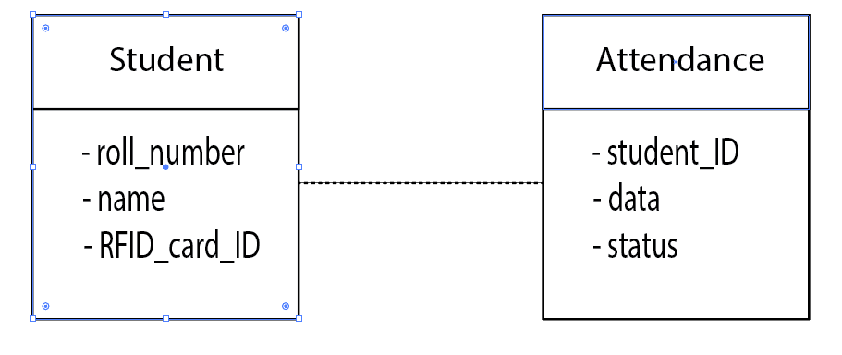

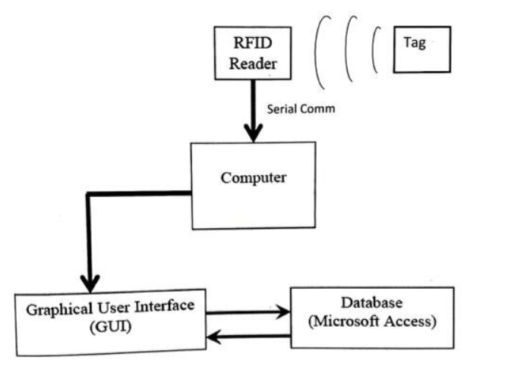

9. Testing Strategy

* Unit testing for frontend and backend components.
* Integration testing for hardware integration.
* User acceptance testing for overall functionality.

10. Deployment Plan

* Deploy frontend and backend on a cloud platform like Vercel.
* Configure ESP32 and RFID modules for hardware integration.

11. Maintenance Plan

* Regular updates and bug fixes.
* Monitoring for security vulnerabilities.
* Continuous improvement based on user feedback.

12. Glossary

1. **RFID: Radio Frequency Identification**

* RFID is a technology that uses electromagnetic fields to automatically identify and track tags attached to objects or individuals.
* RFID systems consist of three main components: tags, readers, and antennas. Tags, also known as RFID transponders or chips, contain electronically stored information. Readers, or RFID scanners, send and receive radio signals to communicate with tags. Antennas facilitate the transmission of signals between tags and readers.
* RFID technology is widely used in various industries for applications such as access control, inventory management, and supply chain logistics. In the context of the IoT Student Tracker project, RFID technology is utilized to track student attendance in real-time. Each student is assigned a unique RFID card, which they can scan upon entering the classroom. The RFID scanner communicates with the web application, automatically recording student attendance.

1. **ESP32: Microcontroller for IoT Applications**

* The ESP32 is a powerful microcontroller developed by Espressif Systems, specifically designed for Internet of Things (IoT) applications.
* It features a dual-core processor, Wi-Fi and Bluetooth connectivity, and a wide range of built-in peripherals, making it ideal for IoT projects requiring wireless communication and processing capabilities.
* The ESP32 microcontroller is highly versatile and can be programmed using various development environments and programming languages, including the Arduino IDE and MicroPython.
* In the context of the IoT Student Tracker project, the ESP32 microcontroller is used to interface with the RFID scanner and communicate with the web application. It facilitates the real-time transmission of attendance data from the RFID scanner to the backend server, enabling seamless integration between hardware and software components.

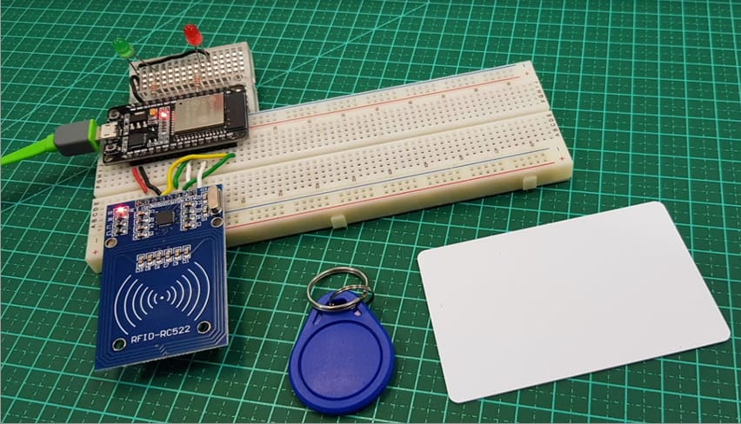s

This design document provides a comprehensive overview of the IoT Student Tracker project, including its objectives, scope, requirements, architecture, and implementation plan. Let me know if you need any further details or modifications!